

***Submitted To:***

*Controller of Examination*

*National University,*

*Gazipur 1704*



***Submitted By:***

*Shoumitro Ray*

*Registration No: 15502000130*

*Session: 2015*

*-*

*2016*

*B.Sc. (Hons.) In CSE*

*National University Bangladesh*



***Supervise By:***

*Jagadish Chandra Roy*

*Assistant Professor,*

*Department of CSE,*

*Delta Computer Science College, Rangpur.*



Delta



**CSE-499 Bachelor of Computer Science and Engineering Part-4, 8th Semester Exam-2019**



**Project on**

**Photo Stock Management System**



***Date of submission: 07***

*January 2021*



***Delta Computer Science College, Rangpur.***

Photo Stock Management System

# Letter of Transmittal

**January 07, 2021**

**Jagadish Chandra Roy (Supervisor)**

Assistant Professor,

Department of Computer Science and Engineering (CSE) Delta Computer Science College, Rangpur.

**Subject**: Submission the Project Report on “***Photo Stock Management System***”.

Dear Sir,

It gave me an immense pleasure in presenting the project report, which was assigned to me as fulfillment of my CSE degree requirement. In this paper, I have tried my level best to carry out all the requirements of a research project.

In preparing this report, I had to gather information about the subject from google, Wikipedia blogs, text book, different articles and different web sites. I have also conducted a survey to find out the problems and solution of the problems.

I consider myself very privileged to prepare this research paper under your guidance. This has been an enormous opportunity for me to learn how to conduct a project program. It has provided me with a great scope of learning ICT of modern invention of the world. I must mention here that I am extremely thankful to you for your valuable guidance, tiresome effort and constant attention whenever required.

Sincerely yours,

_ _ _ _ _ _ _ _ _ _ _

Shoumitro Ray

Registration No: 15502000130

Delta computer Science College (DCSC), Rangpur.

# Student’s Declaration

I am Shoumitro Ray of Computer Science and Engineering (CSE) program from the **Delta Computer Science College, Rangpur** do here by declare that the project report on **Photo Stock *Management System*** has not been submitted by me before, for any degree, diploma, title or recognition.

I here by warrant that the works I have presented do not breach any existing copyright acts.

**Group Member :**

**Name :** Shoumitro Ray

**Registration No :** 15502000130

**Name :** M.Billah

**Registration No :** 15502000118

**Name of student**

Shoumitro Ray

_ _ _ _ _ _ _ _ _ _ _ _ _ Signature

# Supervisor Certificate

This is to certified that ***Shoumitro Ray***, a student of ***Delta computer Science College, Rangpur*** as National University bearing ***Registration No:*** 15502000130, ***Session:*** 2015-16, ***examination year:*** 2019. He has completed successfully his project report on ***Photo Stock Management System*** under my close supervision. He was found very active, sincere and devoted to his word during the preparation of his project report.

I wish his every success and prosperity in all his efforts.

_ _ _ _ _ _ _ _ _ _ _ _ _ _ _ _ _

Signature

**Jagadish Chandra Roy**

Assistant professor,

Department of Computer Science and Engineering (CSE) Delta Computer Science College, Rangpur.

# Dedication

To my parents and the teacher staff of my college … … …

# Acknowledgement

Firstly, I would like to express our gratitude to almighty ***God*** for enabling us strength and opportunity to complete this report within the schedule time successfully.

I am very grateful to my honorable supervisor ***Jagadish Chandra Roy*** for assigning me to prepare this report, which enriches my academic as well as practical knowledge and aptitude. I have got the opportunity to submit this project report on ***Photo Stock Management System***.

Other big thanks to my honorable principal ***Engr. Md. Golam Mostafa,*** for pointing me in the right direction in the short period of time. The help given was most appreciated and help to give a better understanding on which areas of the dissertation needed to be improved.

We also remember the support of the teacher and stuff of CSE department who help us in various ways to reach our goal. We would like to thank all of my friends who help me in different steps in our project and encouragements.

I have tried to fulfill my responsibility as much as possible to make this report attractive but some errors may occur without my intension. So, I am requesting to pardon me and accept my report as the precious fruit on my hard work.

**Thanks, from**

Shoumitro Ray

Registration No: 15502000130

Delta Computer Science College, Rangpur.

# Abstract

This report is prepared on the basis of knowledge and experience gained during the project preparing time. The prime objective of this project is to know the “***Photo Stock Management System***”. This project used by different business company. Customer can create an account and buy your choice product. In this project have login system and registration system for user registration and login. Consists banking transition system for payment. This project developed using multiple technology that HTML5, CSS3, J2EE, JSP, Java, MySQL database and JavaScript.

# Table of Contents

Page No

Letter of Transmittal  i

Student declaration  ii

Supervisor Certificate iii

Dedication  iv

Acknowledgment  v

Abstract vi

Table of Content vii-viii

List of figure  vii-ix

References  61

**Chapter-1**  ***Introduction*** 10-12

1.1 Introduction 11

1.2 Goals and Objective  11

1.3 Overview 11

1.4 List of Activity in this Project 12

**Chapter-2**  ***Analysis***  13-16

2.1 The Systems Development Life Cycle (SDLC) 14

2.2 Why choose waterfall model? 14

2.3 Waterfall Model 15

2.4 Advantage 15

2.4 Project Schedule Gantt Chart 16

**Chapter-3** ***System Design*** 17-42

3.1 Introduction  18

3.2 UML Diagram 18

3.3 Database Diagram 18

3.4 Use Case Diagram 18

3.5 Sequence Diagram 22

3.6 Collaboration Diagram 23

3.7 State Chart Diagram 24

3.8 Activity Diagram 25

3.9 Component Diagram 26

3.10 Deployment Diagram 27

3.11 Data Flow Diagrams 27

3.12 Context level DFD – 0 level 27

3.13 1st Level Admin Side DFD 28

3.14 1st Level User Side DFD 29

3.15 E-R Diagram 30

3.20 Database Tables 35

**Chapter-4** ***Tools and Technology*** 43-45

4.1 Introduction  44

4.2 Tools & Technology 44

4.3 Overview of Technology used 44

**Chapter-5** ***Testing*** 46-47

5.1 Introduction  47

5.2 Unit Test 47

5.3 Integration Testing 47

5.4 Validation Testing 47

**Chapter-6** ***Interface Design*** 48-58

6.1 Introduction 49

6.2 Client Side Interface 49

6.3 Admin Side Interface 55

6.4 Device Support 58

**Chapter-7** ***Conclusion and Future Plan*** 59-60

7.1 Results & Challenges 60

7.2 Challenges 60

7.3 Limitation  49

7.4 Conclusion  49

7.5 Future Plan 49

# List of Figures

Figure No. Figure Name Page No.

2.1 Waterfall Model 15

2.2 Schedule Gantt Char 16

3.1 Use Case Diagram 19

3.2 Use Case Diagram 20

3.3 Use Case Diagram 21

3.4 Sequence Diagram 22

3.5 Collaboration Diagram 23

3.6 State Chart Diagram 24

3.7 Activity Diagram 25

3.8 Component Diagram 26

3.9 Deployment Diagram 27

3.10 o – Level DFD for Online shopping 28

3.11 1st Level – Admin Side DFD 28

3.12 1st Level – User Side DFD 29

3.13 E-R diagram [part 1] 31

3.14 E-R diagram [part 2] 32

3.15 E-R diagram [part 3] 33

3.16 E-R diagram [part 4] 34

3.17 E-R diagram [part 5] 35

# CHAPTER ONE

**INTRODUCTION**

**Introduction**

## 1.1 Introduction

The Photo Stockmanagement system is the online shopping system project. This project document completely describes *what* the “Shopping Cart” should do without describing *how* the software will do it. The basic goal of the requirement phase is to produce the SRS, which describing the complete external behavior of the purposed software.

## 1.2 Goals and objective:

The main purpose of photo stock management system is to provide the image store and sell on the Internet. This online shopping system project software also helps to automate the process of ordering the images in home using internet. The goals of photo stock management system are:

* To automate the times consuming process to go to image store and purchases images.
* To advertise the new images available in Internet.
* To manage the records of customers, Images Details, Stock Details.
* To provide a searchable database of all customers and accounts.
* To minimize the amount of paper work required in the daily services.
* To provide a secure interface for the banking transactions.
* To provide an interface so that online shopping system project report user can take advantage of anytime, anywhere Shopping.

## 1.3 Overview

I decided to study the existing Shopping process like Searching Images, view image details, secure money transfer. In this online shopping system project phase we have also collect necessary information regarding the details to be stored by the database for opening an account.

Finally, it was identified that online shopping system project report the Shopping Website should:

Enable the visitors to fill Registration form.

* Provide details of the various Images available in Stores.
* Provide the information about the rate of the available Images.
* Be secure enough against the malicious security attack, identity verification of the registered user and authorization.
* Be able to handle various run time exceptions and errors.
* It should provide proper interfaces to manage and view details.
* The web pages should be user friendly and well design to attract visitors.

## 1.4 List of activity in this project

* Login activity
* Registration activity
* Profile activity
* Home activity
* Account activity
* Contact activity
* Buy activity
* Pricing activity
* Search activity
* Order activity

# CHAPTER TWO

**SYSTEM ANALYSIS**

**System Analysis**

## 2.1 The Systems Development Life Cycle (SDLC)

It is a conceptual model used in project management that describes the stages involved in an information system development project from an initial feasibility study through maintenance of the completed application. Various SDLC methodologies have been developed to guide the processes involved including the waterfall model (the original SDLC method). Some methods work better for specific types of projects, but in the final analysis, the most important factor for the success of a project may be how closely particular plan was followed.

A Software Development Life Cycle is essentially a series of steps, or phases, that provide a model for the development and lifecycle management of an application or piece of software. The Software Development Life Cycle is a process that ensures good software is built. Each phase in the life cycle has its own process and deliverables that feed into the next phase*.[1]*

SDLC Models are

* Water Fall Model
* The Prototyping model / Evolutionary development
* Spiral Model
* The Incremental model
* Agile Model

## 2.2 Why choose waterfall model?

For following case we used this model

* My requirements are very well known, clear and fixed.
* Product definition is stable.
* Technology is understood.
* There are no ambiguous requirements
* Ample resources with required expertise are available freely
* The project is not so long.

## 2.3 Waterfall model

Here using waterfall model for this project.



**Fig** 2.1: Waterfall Model *[1]*

## 2.4 Advantage

* The waterfall model is that documentation is produced at each phase and that it fits with other engineering process models.
* Disciplined approach
* Careful checking by the Software Quality Assurance Group at the end of each phase.
* Documentation available at the end of each phase
* Linear model.
* Easy to understand and implement
* Identifies deliverable and milestones

## 2.5 Project Schedule Gantt Chart

Following figure shows the Schedule of this project. How much time it take to complete. It also shows which part take how much time for completing this project.

|  |  |  |  |  |  |  |  |  |  |  |  |  |  |  |  |  |
| --- | --- | --- | --- | --- | --- | --- | --- | --- | --- | --- | --- | --- | --- | --- | --- | --- |
| Time | W  1 | W  2 | W  3 | W  4 | W  5 | W  6 | W  7 | W  8 | W  9 | W  10 | W  11 | W  12 | W  13 | W  14 | W  15 | W  16 |
| Customer  Communication |  |  |  |  |  |  |  |  |  |  |  |  |  |  |  |  |
| Analysis |  |  |  |  |  |  |  |  |  |  |  |  |  |  |  |  |
| Design |  |  |  |  |  |  |  |  |  |  |  |  |  |  |  |  |
| Coding |  |  |  |  |  |  |  |  |  |  |  |  |  |  |  |  |
| Testing |  |  |  |  |  |  |  |  |  |  |  |  |  |  |  |  |
| Implementation |  |  |  |  |  |  |  |  |  |  |  |  |  |  |  |  |

**Fig** 2.2 : Schedule Gantt Char

# CHAPTER THREE

**SYSTEM DESIGN**

**System Design**

## 3.1 Introduction

Systems design is the process of defining the architecture, modules, interfaces, and data for a system to satisfy specified requirements. Systems design could be seen as the application of systems theory to product development. There is some overlap with the disciplines of systems analysis, systems architecture and systems engineering.

## 3.2 UML Diagram

UML (Unified Modeling Language) is a general-purpose, graphical modeling language in the field of Software Engineering. During the development of this software a set of diagrams are used. This diagram developed before designing this project.

List of this diagram are:

* Use Case Diagram
* Sequence Diagram
* Collaboration Diagram / Communication Diagram
* State Chart Diagram / State Machine Diagram / State Transition diagram
* Activity Diagram
* Component Diagram
* Deployment Diagram

## 3.3 Database Diagram

* Data Flow Diagram
* E-R Diagram

## 3.4 Use Case Diagram

Here, the top-level uses are as follows; View Items, Make Purchase, Checkout, Client Register. The View Items use case is utilized by the user who searches and view products. The Client Register use case allows the customer to register itself. It is to be noted that the Checkout is an included use case, which is part of Making Purchase, and it is not available by itself.



Fig 3.1: Use Case Diagram for Client

The View Items is further extended by several use cases such as; Search Items, Browse Items, View Recommended Items, Add to Shopping Cart, Add to Wish list. All of these extended use cases provide some functions to users, which allows them to search for an item. The View Items is further extended by several use cases such as; Search Items, Browse Items, View Recommended Items, Add to Shopping Cart, Add to Wish list. All of these extended use cases provide some functions to users, which allows them to search for an item.

Both View Recommended Item and Add to Wish List include the user Authentication use case, as they necessitate authenticated users, and simultaneously item can be added to the shopping cart without any user authentication.



Fig 3.2: Use Case Diagram for Gallery

Similarly, the Checkout use case also includes the following use cases, as shown below. It requires an authenticated Web user, which can be done by login page, user authentication cookie ("Remember me"), or Single Sign-On (SSO). SSO needs an external identity provider's participation, while Web site authentication service is utilized in all these use cases.

The Checkout use case involves Payment use case that can be done either by the credit card and external credit payment services or with PayPal.



Fig 3.3 : Use Case Diagram for Checkout

## 3.5 Sequence Diagram



Fig 3.4 : Sequence Diagram

## 3.6 Collaboration Diagram



**Fig 3.5 :** Collaboration Diagram for Client

## 3.7 State Chart Diagram



**Fig 3.6 :** State Chart Diagram for Client

## 3.8 Activity Diagram



**Fig 3.7:** Activity Diagram for Client

## 3.9 Component Diagram



**Fig 3.8 :** Component Diagram

## 3.10 Deployment Diagram



**Fig 3.9:** Deployment Diagram

## 3.11 Data Flow Diagrams

A data flow diagram is a graphical view of how data is processed in a system in terms of input and output.

## 3.12 Context level DFD – 0 level

The context level data flow diagram (DFD) is describe the whole system. The (o) level DFD describe the all user module who operate the system. Below data flow diagram of photo stock management system shows the two users can operate the system Admin and Member user.



**Fig 3.10 :** o – Level DFD

## 3.13 1st Level Admin Side DFD

The Admin side DFD describe the functionality of Admin, Admin is a owner of the website. Admin can first add category of item and then add items by category wise. and admin can manage order and payment detail.



**Fig 3.11:** 1st Level – Admin Side DFD

## 3.14 1st Level User Side DFD

The user is all people who operate or visit our website. User is a customer of a website. User can first select product for buy, user must have to register in our system for purchase any item from our website. after register he can login to site and buy item by making online payment through any bank debit card or credit card.



**Fig 3.12 : 1st Level – Client Side DFD**

## 3.15 E-R Diagram (part 1)



**Fig 3.13:** E-R diagram [part 1]

## 3.16 E-R Diagram (part 2)



**Fig 3.14:** E-R diagram [part 2]

## 3.17 E-R Diagram (part 3)



**Fig 3.15:** E-R diagram [part 3]

## 3.18 E-R Diagram (part 4)



**Fig 3.16:** E-R diagram [part 4]

## 3.19 E-R Diagram (part 5)



**Fig 3.17:** E-R diagram [part 5]

## 3.20 Database Tables

All database table are given below and also describe these database table

### Admin

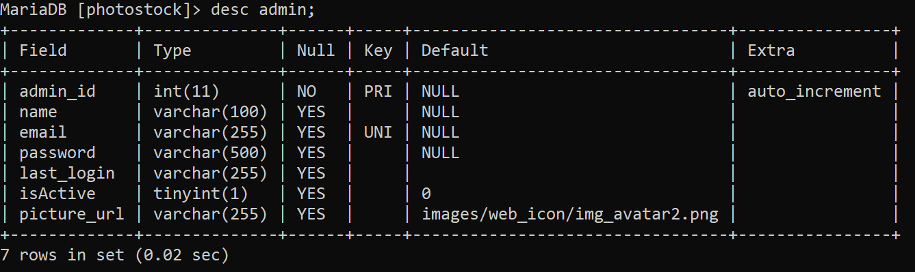

### User

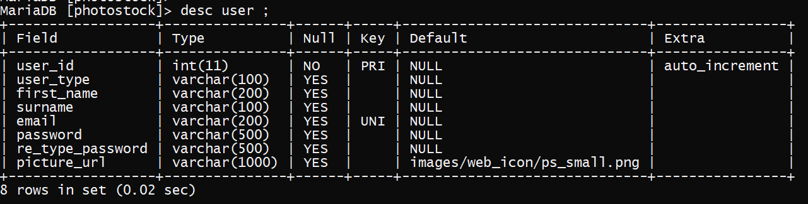

### user_active

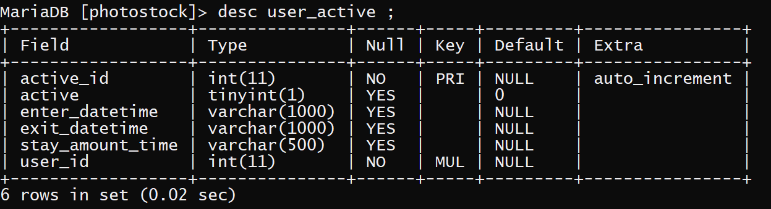

### simple_user

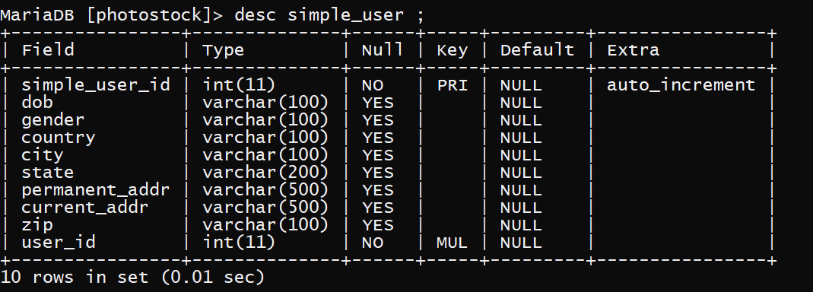

### company_user

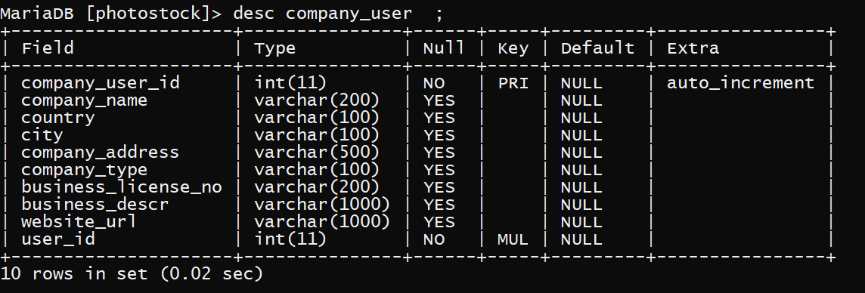

### company_contact_person

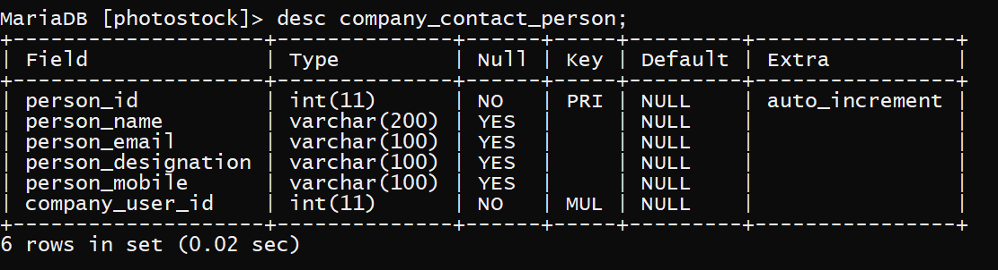

### Contact

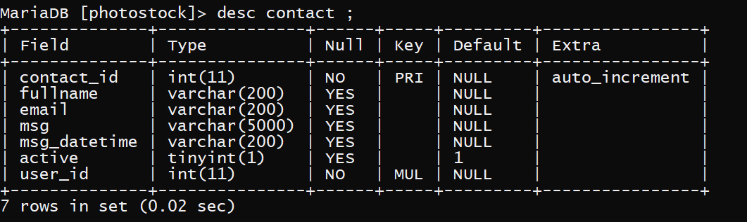

### Designer

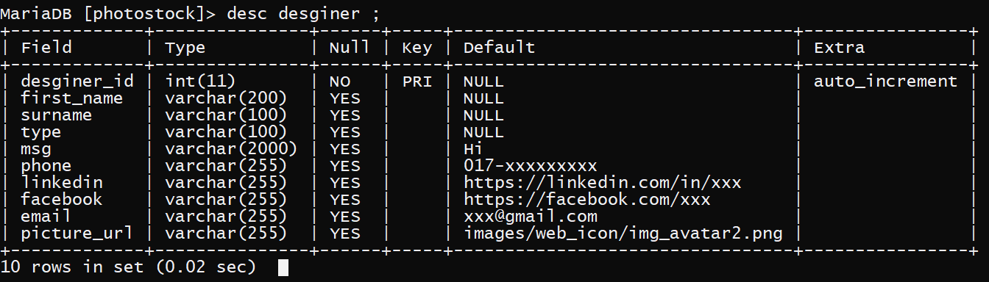

### Work

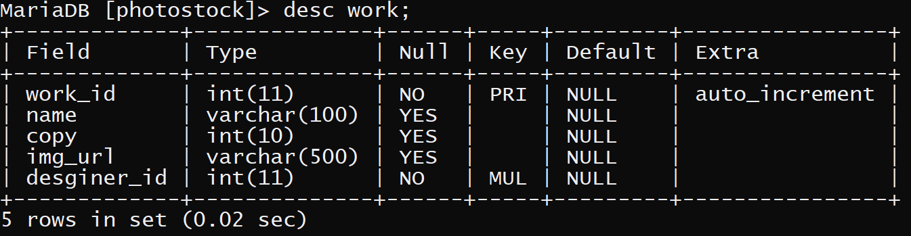

### Category

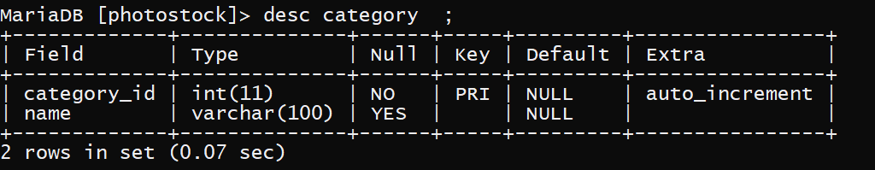

### image

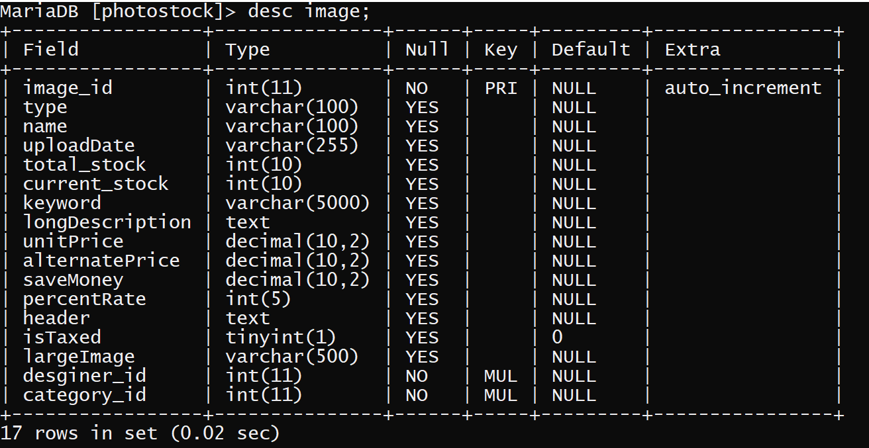

### image_rating_review

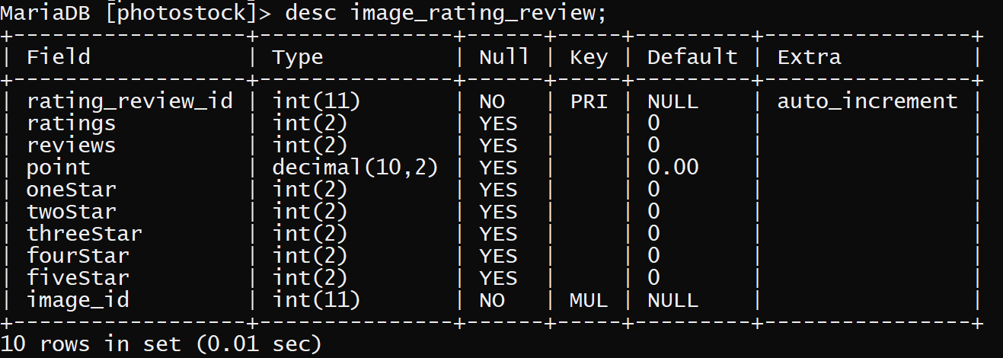

### image_comment

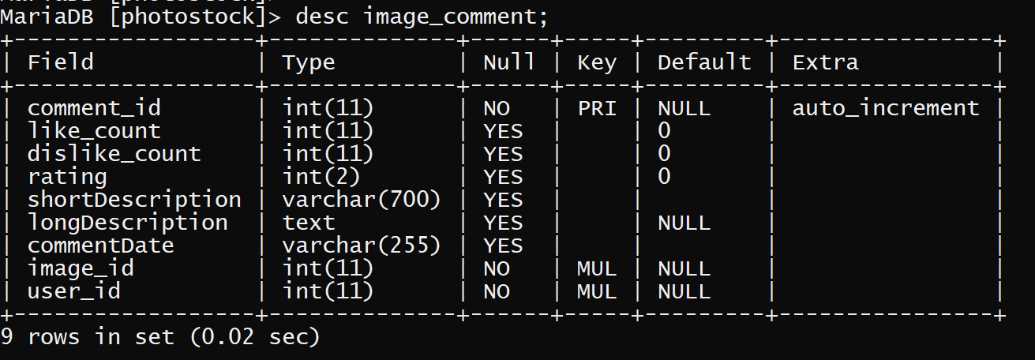

### comment_like

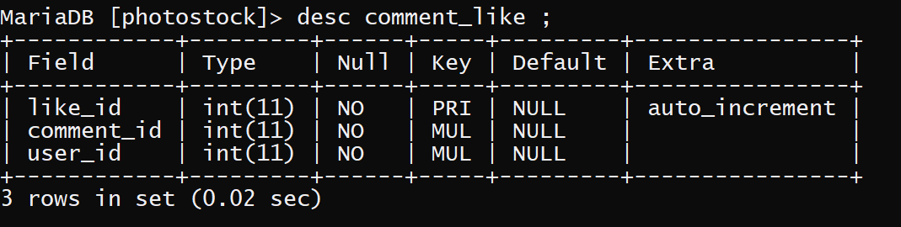

### comment_dislike

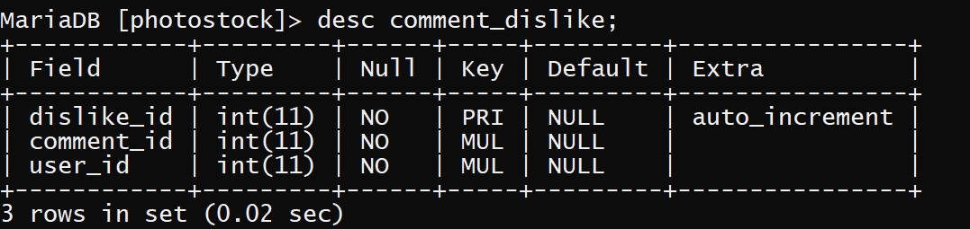

### Shopping

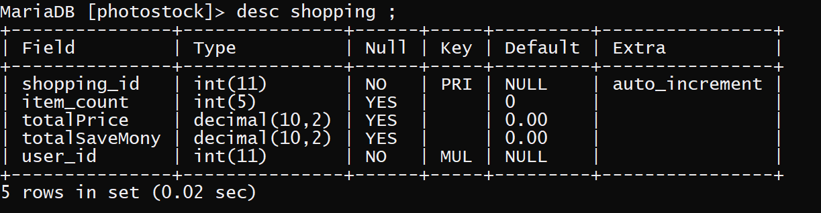

### shopping_cart

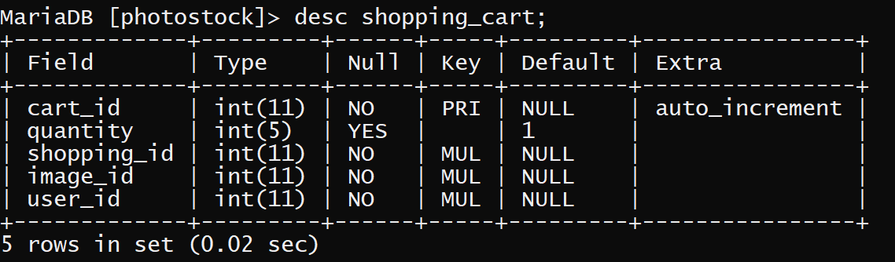

### Wishlist

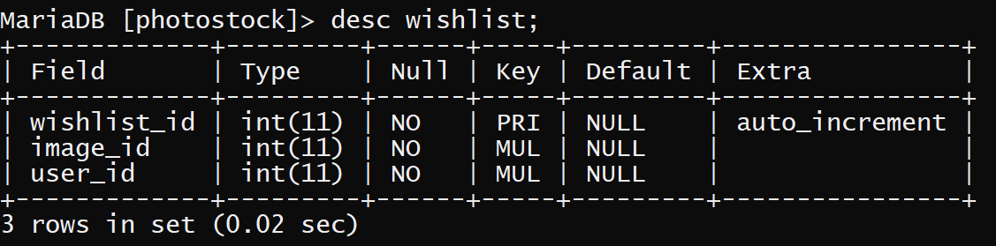

### billing_addr

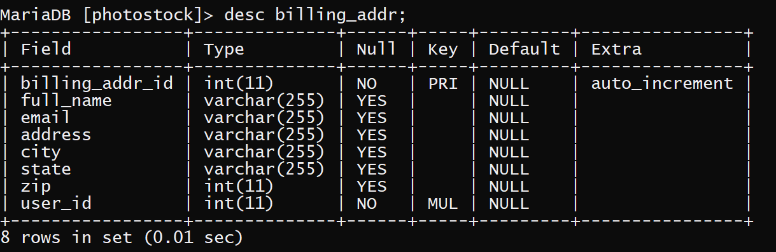

### credit_card

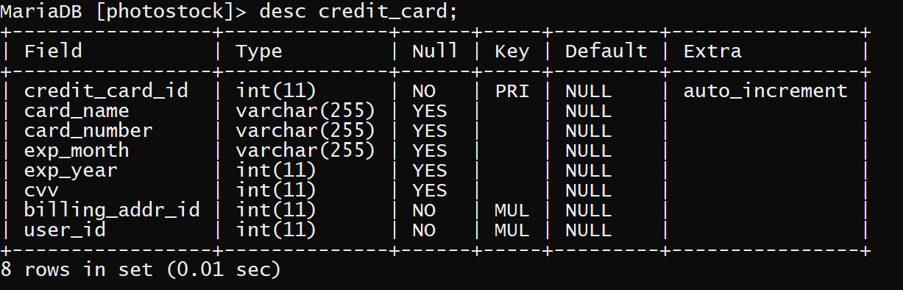

### credit_card_trim

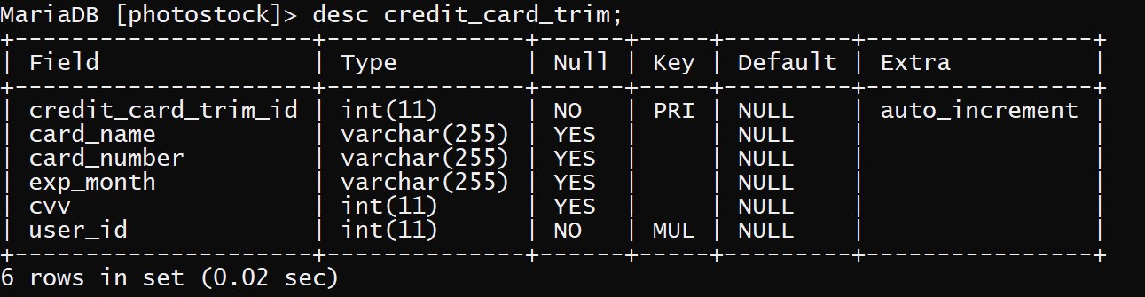

### Payment

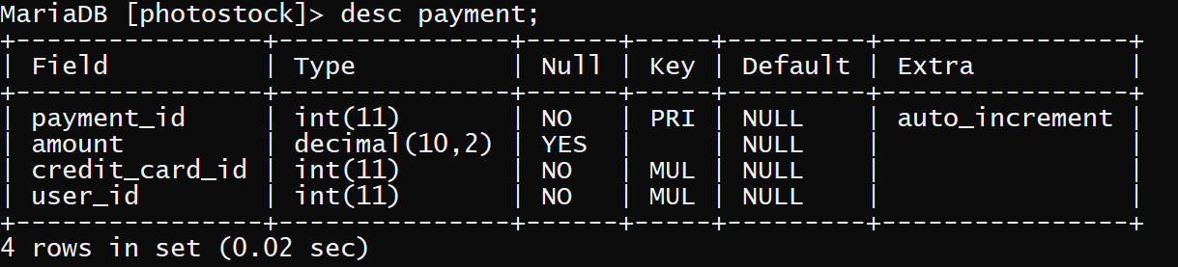

### invoice_image

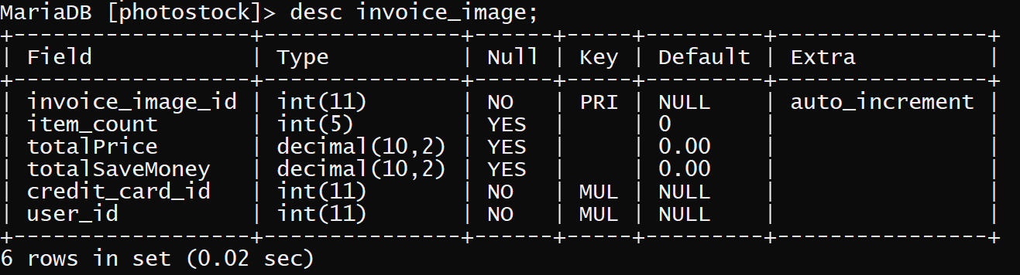

### invoice_image_history

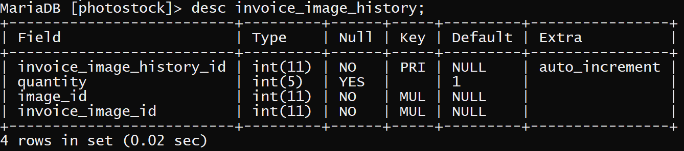

### order_item

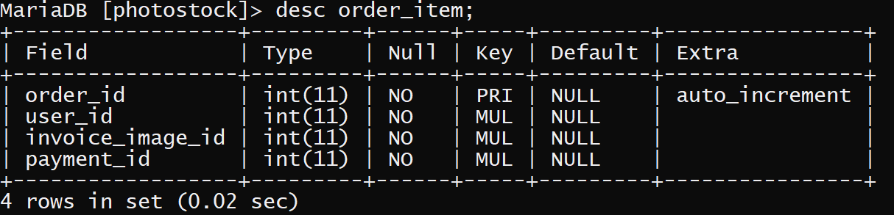

### purchase_item

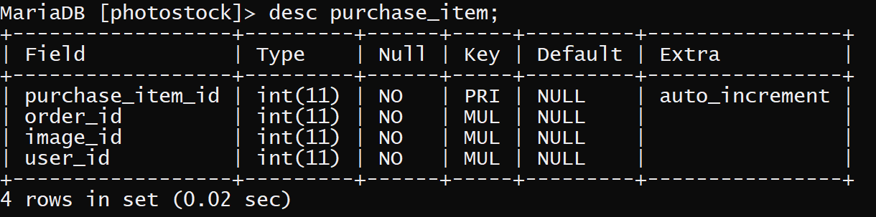

### Notice

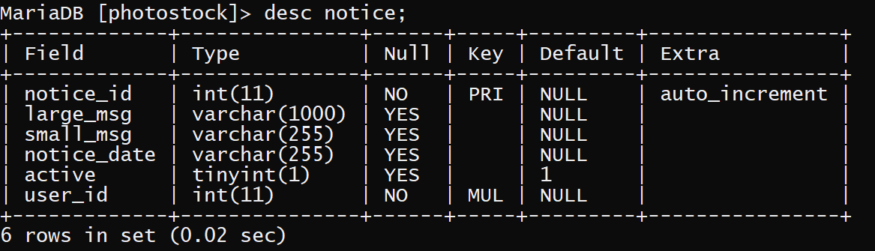

### visited_users_count

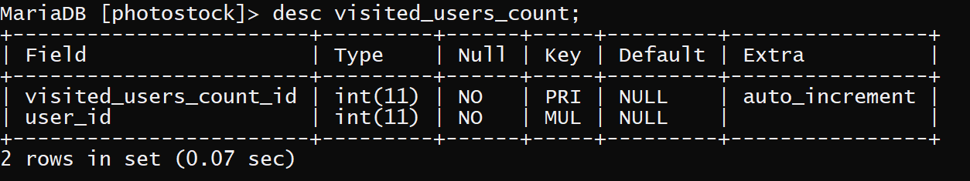

### visited_users_chart

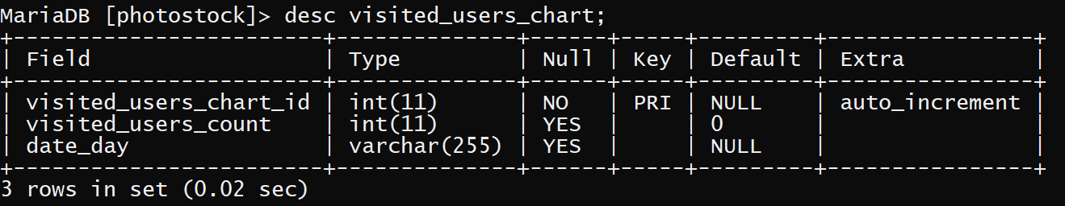

# CHAPTER FOUR

**TOOLS & TECHNOLOGY**

**Tools & Technology**

## 4.1 Introduction

The tools and technology such things that are used to develop the project. Various web tools are used for development. Any types of project for development need a tool that is provide an environment to develop the project.

## 4.2 Tools & Technology

There are some used tools for this system.

* Netbeans 8.2
* HTML 5
* JavaScript
* CSS 3
* MySQL database
* Tomcat server
* JSP
* Java
* JSON
* AJAX

## 4.3 Overview of Technical used

What is WEB? The web is a hypermedia-based structure which provides a source of browsing information over the internet in a non-sequential format by the use of hyperlinks which redirects users to more resources and information.

### HTML

HTML, which stands for Hyper Text Markup Language*,* is the predominant markup language for web pages. It provides a means to create structured documents by denoting structural semantics for text such as headings, paragraphs, lists etc. as well as for links, quotes, and other items, it allows images and objects to be embedded and can be used to create interactive forms.*[4][2]*

### CCS

CCS is abbreviated as Cascading Style Sheet and is used for describing how HTML elements need to be displayed when they are represented in a web page format or other media. It also helps in saving a lot of work because controlling the layout of multiple web pages can be done all at a time*.[2][5]*

### JavaScript

JavaScript is an object-based scripting language, which is very popular and used to create dynamic and interactive web pages. JavaScript is an interpreted language that is usually used with HTML, and programs written in JavaScript are called scripts which are lightweight. *[6]*

### MySQL

MySQL is an open-source, fast reliable, and flexible relational database management system, typically used with PHP. MySQL is a database system used for developing web-based software applications. *[3][7][8]*

### Tomcat server

The Apache Tomcat software is an open source implementation of the Java Servlet, Java Server Pages, Java Expression Language and Java Web Socket technologies.

Apache Tomcat is usually used as a Servlet Container even though Tomcat has a fully functional HTTP Server to serve static content. In most of production, Tomcat is used in conjunction with Apache HTTP Server where Apache HTTP Server attends static content like html, images etc., and forwards the requests for dynamic content to Tomcat. This is because Apache HTTP Server supports more advanced options than that of Tomcat. *[9]*

### JSP

JSP stands for Java Server Pages. It is a server side technology. JSP used for creating web application. It is used to create dynamic web content.*[9][10]*

The Lifecycle of a JSP Page

* Translation of JSP Page
* Compilation of JSP Page
* Classloading (the classloader loads class file)
* Instantiation (Object of the Generated Servlet is created).
* Initialization ( the container invokes jspInit() method).
* Request processing ( the container invokes _jspService() method).
* Destroy ( the container invokes jspDestroy() method

# CHAPTER FIVE

**TESTING**

**Testing**

## 5.1 Introduction

Software testing is a process of running with intent of finding errors in software. Software testing assures the quality of software and represents final review of other phases of software like specification, design, code generation etc.

## 5.2 Unit test

I have tested each view/module of the application individually. As the modules were built up testing was carried out simultaneously, tracking out each and every kind of input and checking the corresponding output until module is working correctly.

## 5.3 Integration test

In my project I have done integration testing. In this project I have started construction and testing with atomic modules. After unit testing the modules are integrated one by one and then tested the system for problems arising from component interaction.

## 5.4 Validation Testing

It provides final assurances that software meets all functional, behavioral & performance requirement. Black box testing techniques are used.

There are three main components

* Validation test criteria.
* Configuration review (to ensure the completeness of s/w configuration.) - Alpha & Beta testing
* Alpha testing is done at developer’s site i.e. at home & Beta testing once it is deployed. Since I have not deployed my application, I could not do the Beta testing.

# CHAPTER SIX

**Interface Design**

**Interface Design**

## 6.1 Introduction

This is one of the main task of the developer to design a graphical user interface that user attracts to and can use easily, in one word it should be user friendly. So for this we should have better understanding of customers likes and dislikes and the features that are in trend and mesmerize the public easily, initially we need to locate the targeting people that what kind of application do they need. After giving all this information we should start to design the application. After checking Photo Stock Management System.

This interface divided into two part.

* Client Side interface
* Admin Side interface

## 6.2 Client Side Interface

This user interface design for visitor or client or customer.

#### 6.2.1 Home page

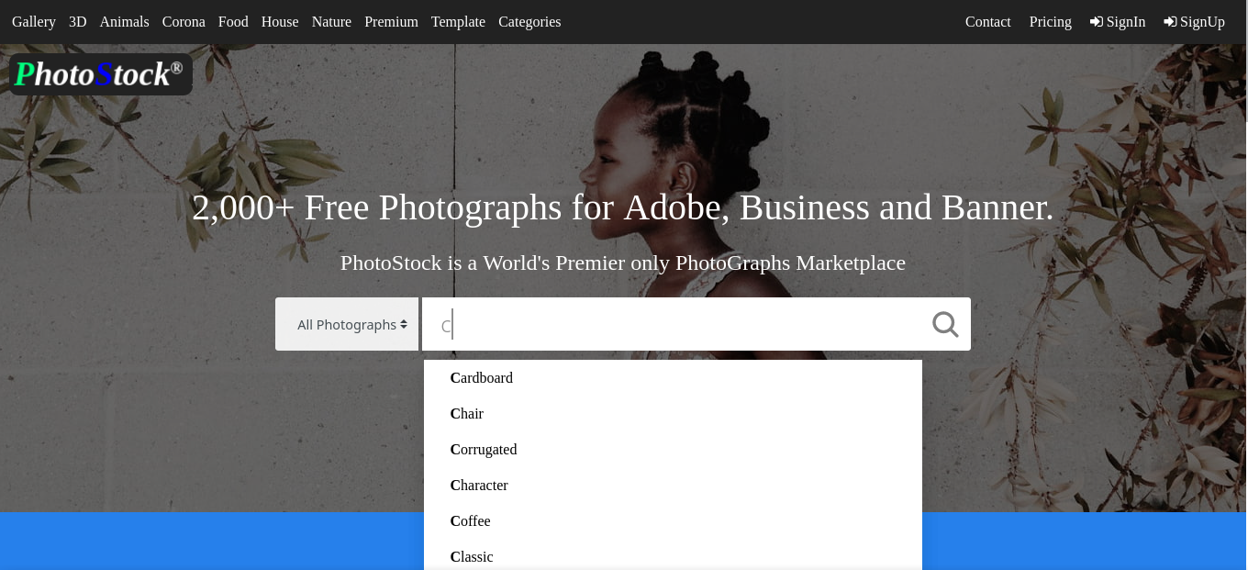

#### 6.2.2 Login Page

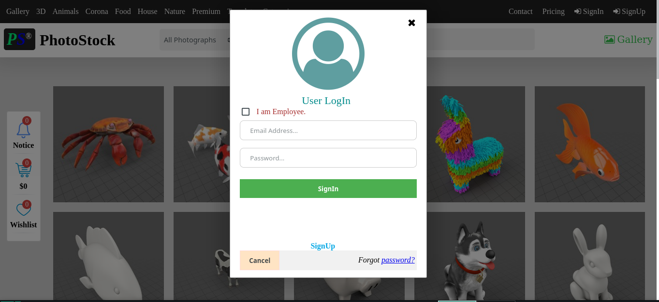

#### 6.2.3 SignUp Page

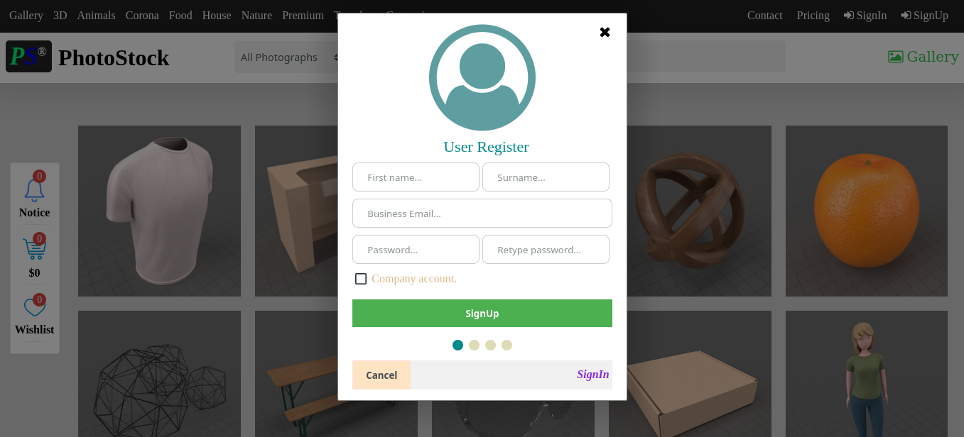

#### 6.2.4 Gallery

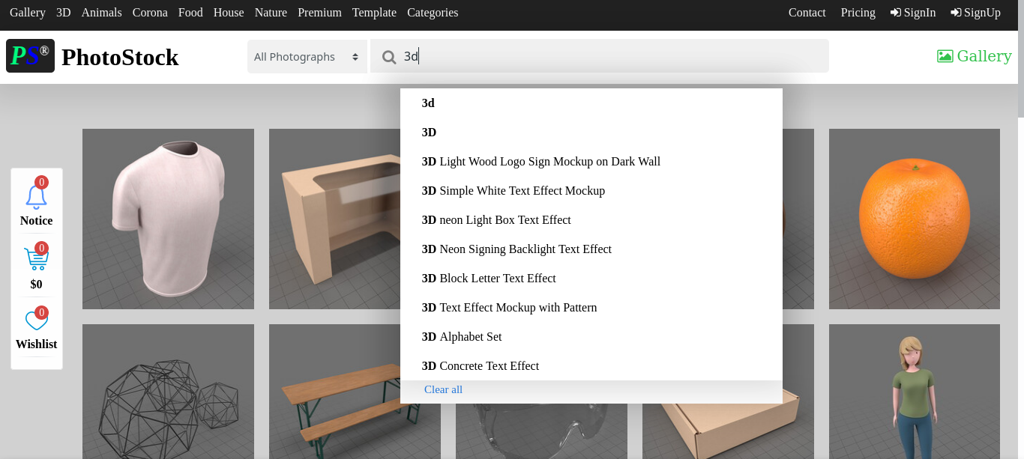

#### 6.2.5 Wish List

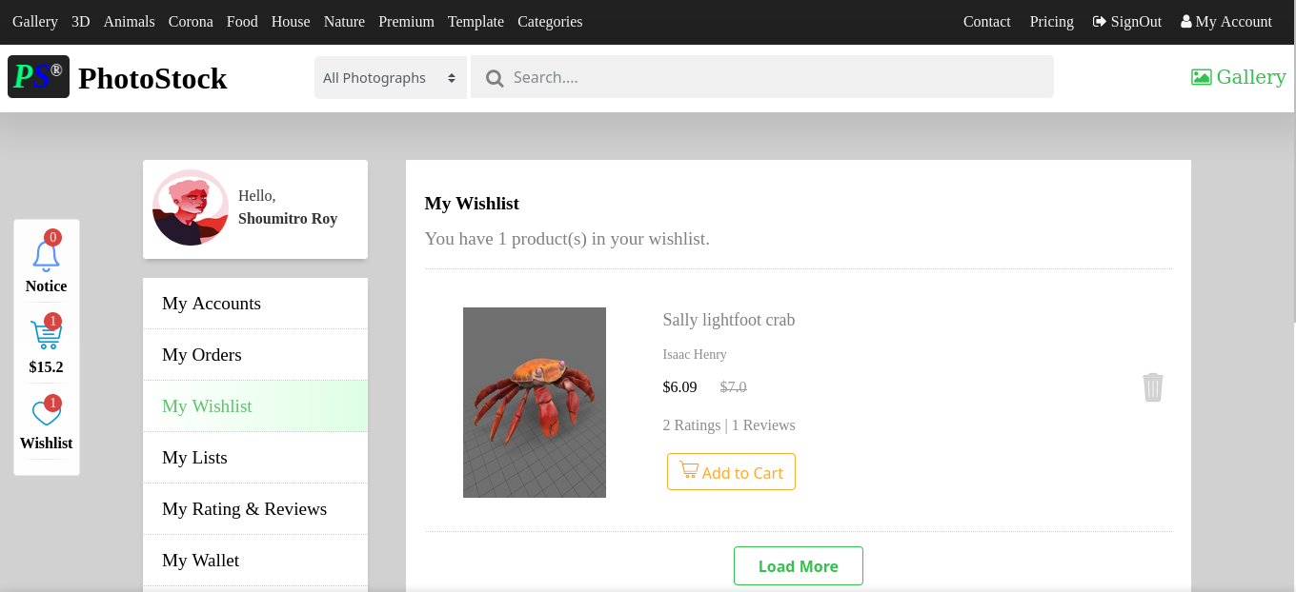

#### 6.2.6 Add To Cart

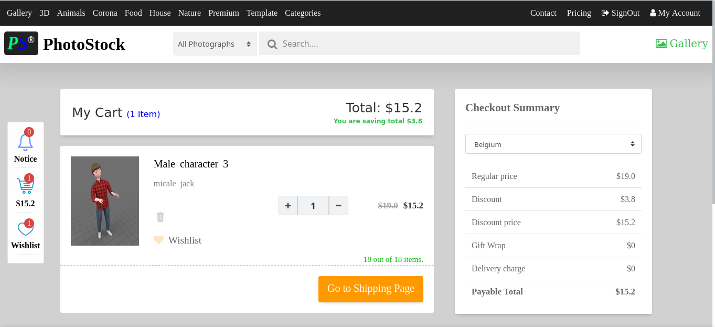

#### 6.2.7 Payment

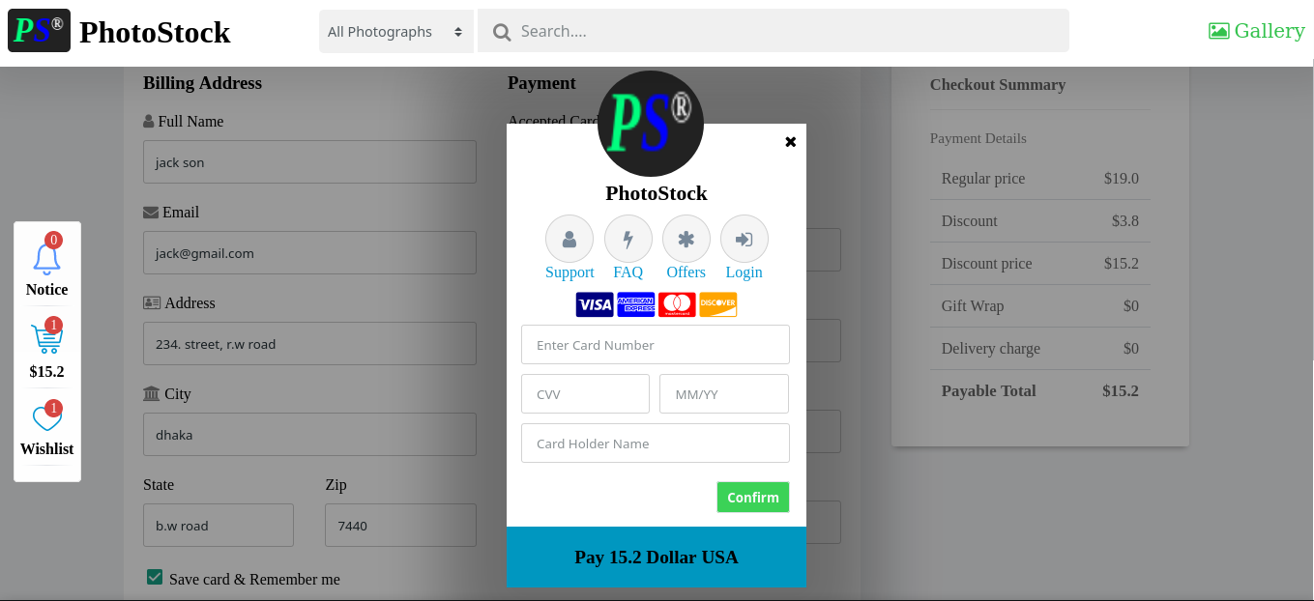

#### 6.2.8 Order

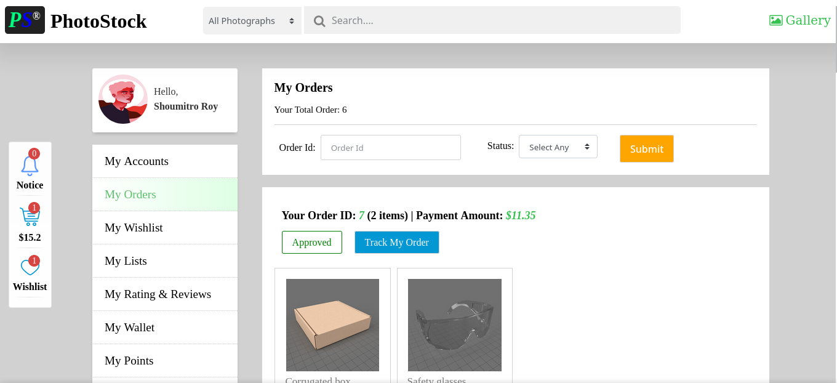

#### 6.2.9 Product

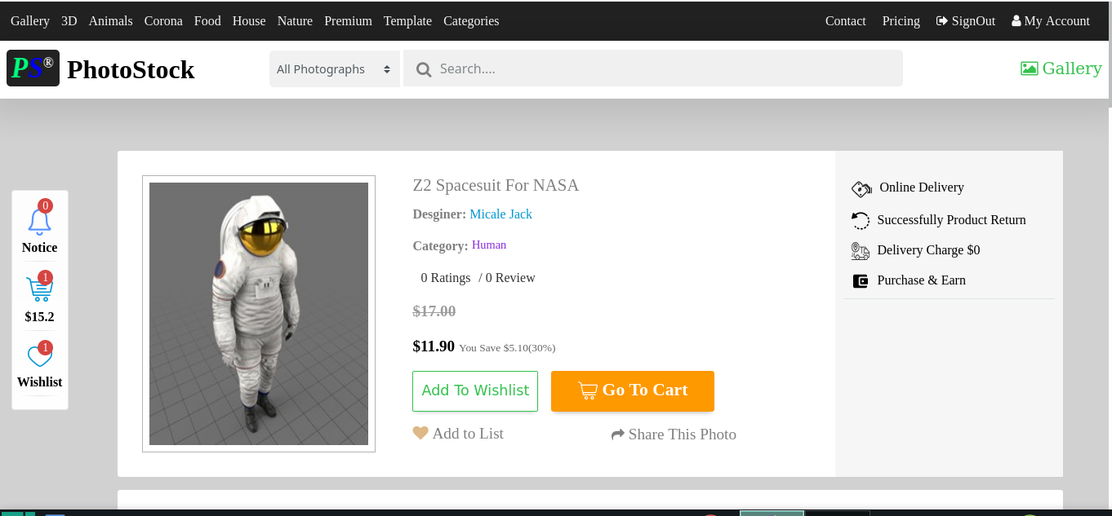

#### 6.2.10 Rating and Review

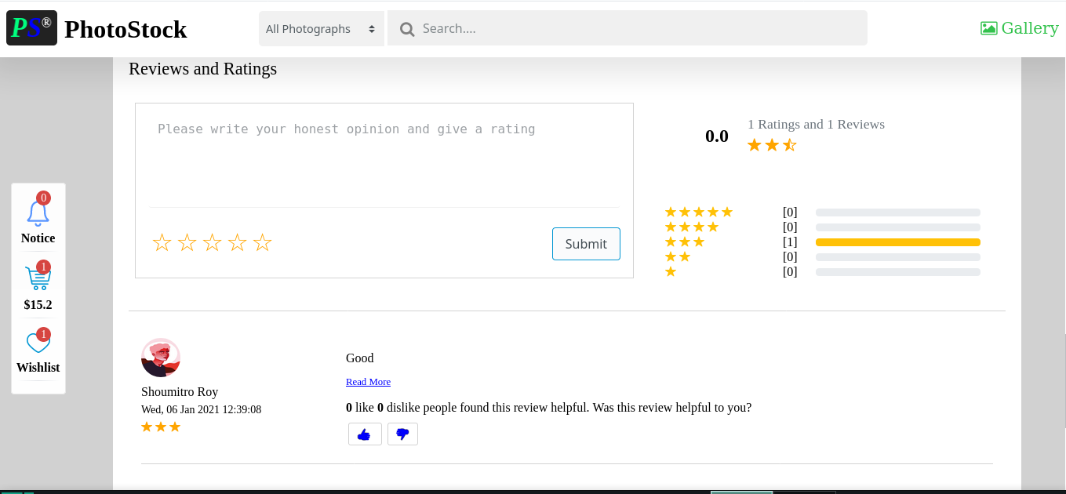

#### 6.2.11 Contact

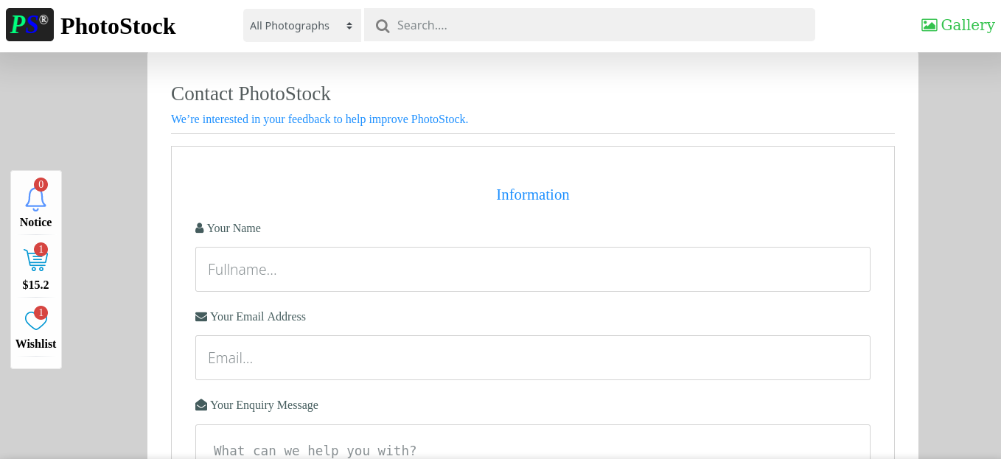

## 6.3 Admin Side Interface

This interface only design for admin.

#### 6.3.1 Admin Login

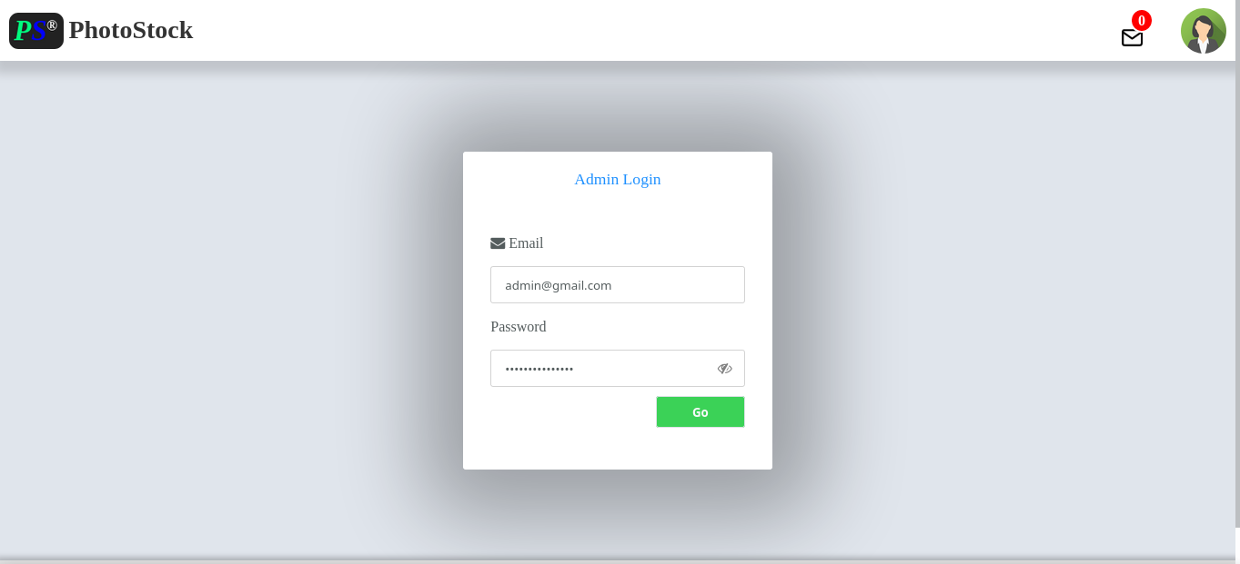

#### 6.3.2 Dashboard

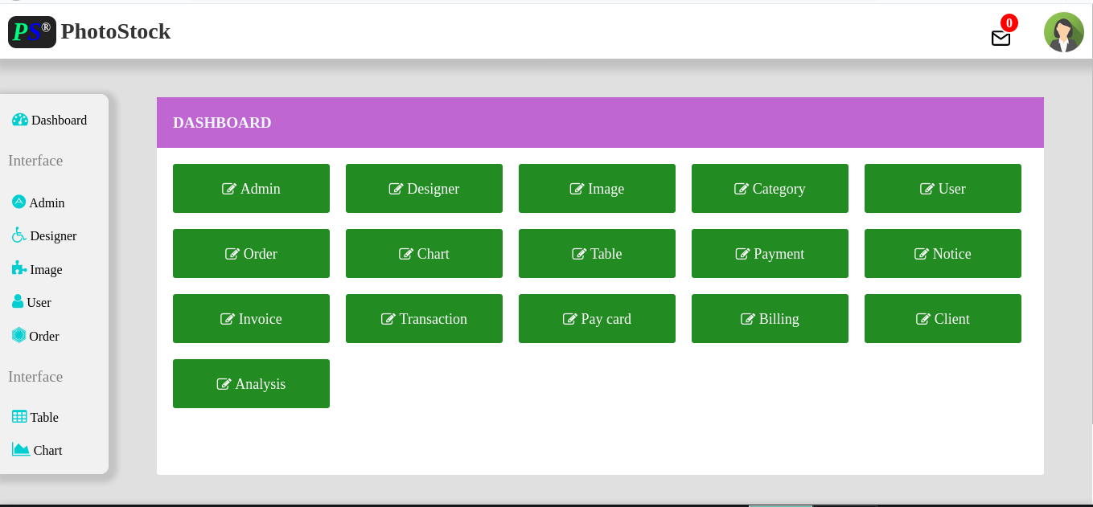

#### 6.3.3 Chart Analysis Page

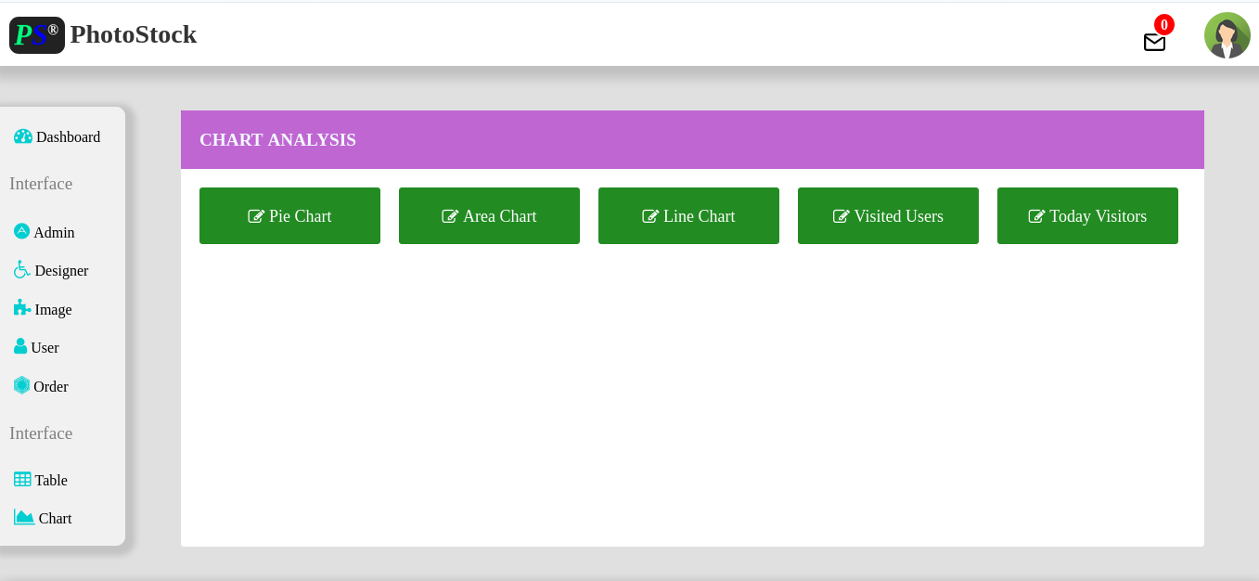

#### 6.3.4 Area Chart

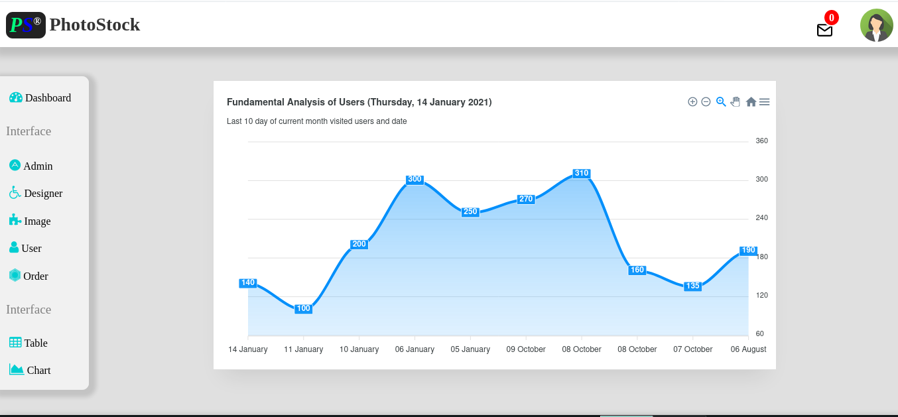

#### 6.3.5 Pie Chart

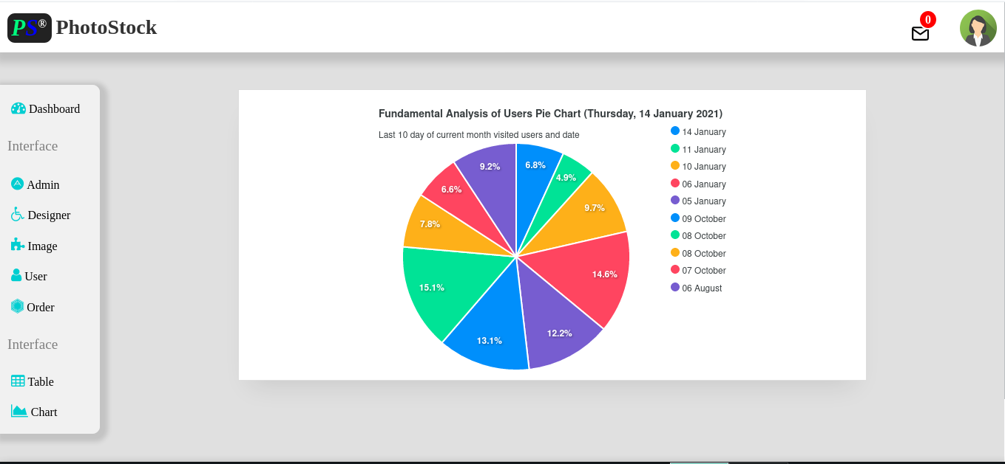

#### 6.3.6 Line Chart

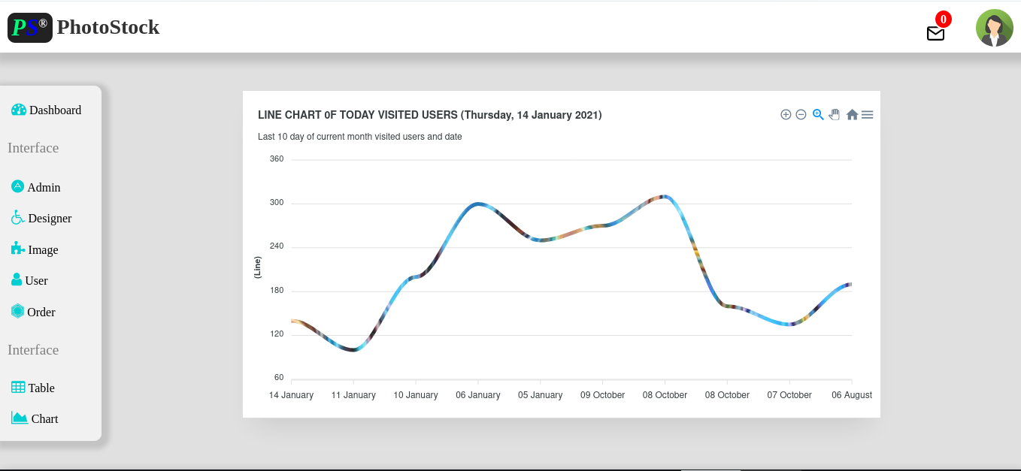

## 6.4 Device Support

This project support tablet and smart phone.

#### 6.4.1 Smart Phone

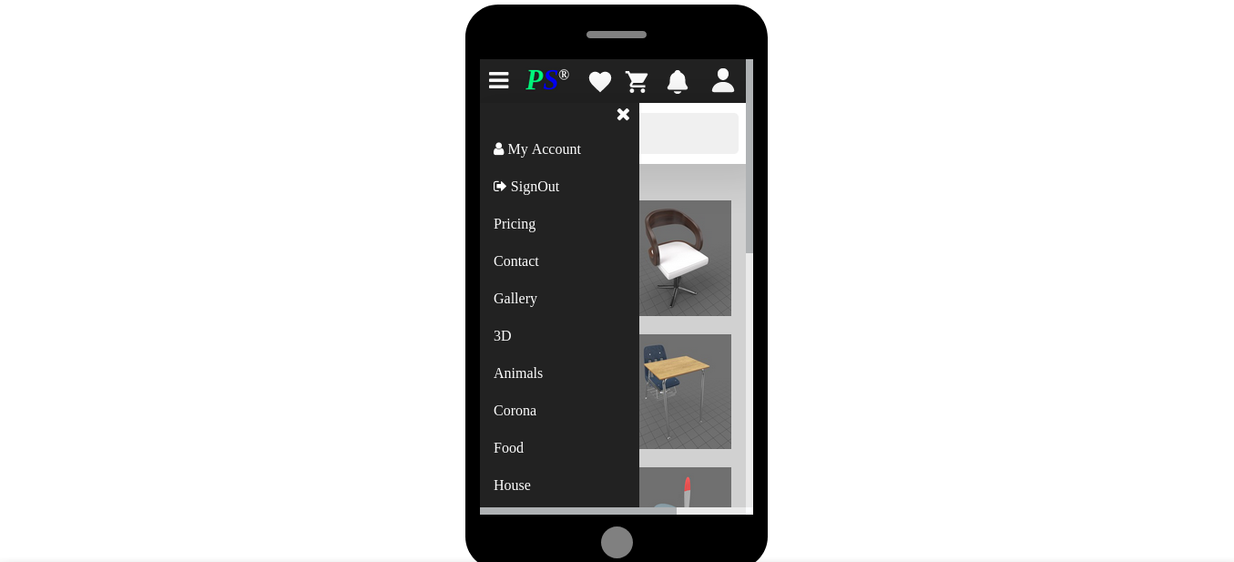

#### 6.4.2 Tablet

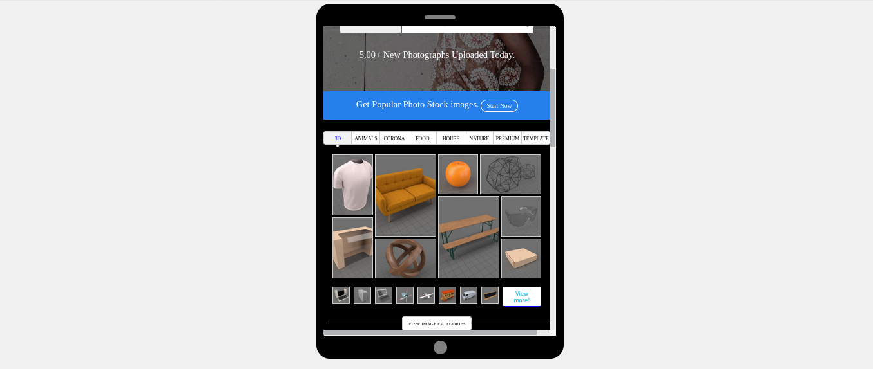

# CHAPTER SEVEN

**CONCLUSION & FUTURE PLAN**

**Conclusion & Future Plan**

## 7.1 Results & Challenges

The application can be used for selling image. It is easy to use, since it uses the GUI provided in the user dialog. User friendly screens are provided. The application is easy to use and interactive making online shopping a recreational activity for users. It has been thoroughly tested and implemented.

## 7.2 Challenges

* Compatibility with browsers like Mozilla Firefox, google chrome etc.
* Using a layered approach in developing the application which would make the application maintainable.

The overall idea of doing this project is to get a real time experience. Learn new technologies.

## 7.3 Limitation

This application does not have a built in check out process. An external checkout package has to be integrated in to this application. Also users cannot save the shopping carts so that they can access later i.e. they cannot create wish lists which they can access later. This application does not have features by which user can set price ranges for products and receive alerts once the price reaches the particular range.

## 7.4 Conclusion

The ‘Photo Stock Management System’ is designed to provide a web base service application that would make searching, viewing and selection of a product easier. The search engine provides an easy and convenient way to search for products where a user can Search for a product interactively and the search engine would refine the products available based on the user’s input. The user can then view the complete specification of each product. They can also view the product reviews and also write their own reviews.

## 7.5 Future Plan

The following things can be done in future.

* The users could subscribe for price alerts which would enable them to receive messages when price for products fall below a particular level.
* The current system is confined only to the shopping cart process. It can be extended to have an easy to use check out process.
* Users can have multiple shipping and billing information saved. During checkout they can use the drag and drop feature to select shipping and billing information.

# References

1. SYSTEN ANALYSIS & DESIGN, THIRD EDITION, ALLAS M. AWAD. 07 January 2020
2. Murach’s HTML5 and CSS 3. Retrieved 15 January 2020.
3. Database System Concepts, Six Edition, Abraham Silberschatz, Henry F.Korth, S. Sudarshan Retrieved 10 January 2020
4. www.w3schools.com/html/default.asp (html). Retrieved 01 January 2020
5. [www.w3schools.com/css/default.asp](http://www.w3schools.com/css/default.asp)(CSS). Retrieve 20 January 2020
6. [www.w3schools.com/js/default.asp](http://www.w3schools.com/js/default.asp)(JavaScript)Retrieve 02 February 2020
7. [www.w3schools.com/sql/default.asp](http://www.w3schools.com/sql/default.asp) (MySQL)Retrieve 27 February 2020
8. [www.mysql.com](http://www.mysql.com/) (MYSQL) Retrieve 03 February 2020
9. www.javatpoint.com/jsp-tutorial (JSP)Retrieve 02 March 2020
10. www.tutorialspoint.com/jsp/index.htm (JSP)Retrieve 23 March 2020